Crakrr: An Automated Web Vulnerability Assessment Tool
Abhishek Saraf1[0009-0004-8769-4777], Alesha Mulla2, Arya Chavan3, Ritik Arora4 and Gopal Deshmukh5
Vishwakarma Institute of Technology, Pune MH 411037, India
1 abhishek.saraf24@vit.edu
2 alesha.mulla24@vit.edu
3 arya.chavan24@vit.edu
4 ritik.arora24@vit.edu
5 sachin.jadhav@vit.edu
Abstract. Digital payment fraud has become a critical challenge in India's rapidly growing UPI ecosystem. Traditional fraud detection systems react after transactions are completed, making them ineffective in preventing losses. This project presents ARGUS (Advanced Real-time Guard & User Security), an AI-powered fraud prevention system that evaluates transaction risk before payment authorization. Using machine learning techniques including XGBoost gradient boosting and Isolation Forest anomaly detection, ARGUS analyzes transaction patterns, user behavior, device information, and velocity metrics to identify fraudulent activities in real-time. The system specifically addresses India-specific fraud patterns such as digital arrest scams, SIM swap attacks, and mule account networks. Our goal is to build a working prototype that demonstrates pre-authorization fraud detection, provides explainable AI decisions, and maintains high detection accuracy while minimizing false positives. This document outlines the project vision, objectives, system architecture, implementation plan, and expected outcomes for the ARGUS fraud detection platform.
Keywords: a, b, c.
- Introduction
The proliferation of digital payment systems in India has fundamentally transformed the nation's financial ecosystem. With smartphone penetration exceeding 700 million users and internet accessibility expanding to tier-2 and tier-3 cities, digital transactions have become the preferred mode of commerce for a significant portion of the population. The Unified Payments Interface (UPI), launched by the National Payments Corporation of India (NPCI) in 2016, has emerged as the backbone of this revolution, facilitating real-time inter-bank peer-to-peer and merchant transactions through mobile platforms. Despite these technological advancements, the rapid digitization of financial services has created unprecedented opportunities for cybercriminals and fraudsters. The Indian Cybercrime Coordination Centre (I4C) reports a 300% increase in digital payment fraud cases between 2021 and 2025, with sophisticated attack vectors including account takeover, social engineering, phishing, and coordinated fraud rings. The economic impact extends beyond direct monetary losses, eroding consumer confidence in digital payment systems and threatening the government's financial inclusion objectives.
ADD MORE CONTENT
- Literature Review
Recent research reveals what appears to be a transition between reactive security measures and proactive, agent-based security [9]. Sheng et al. [1] surveyed the application of Large Language Models (LLMs) in vulnerability detection and testing, noting a key gap in the field: frameworks that actually integrate these language models with traditional security tools are currently lacking. Similarly, Kaur et al. [2] observed that even though AI detection is maturing, automated validation is an open problem highlighting the importance of architectures that validate findings before trusting them. Andrade et al. [10] demonstrated that LLMs are very powerful in comprehending code semantics to identify design flaws. Crakrr is based directly on these ideas. Instead of merely producing text, in our system, we have an independent agent that guides existing security scanners and analyses the behavior of source code in real time.
To be effective at scanning modern applications, tools have to be able to understand complex web structures. Yang et al. [6] have shown that multimodal LLMs are more accurate than standard crawlers for mapping web application logic. Crakrr uses this concept to deal with complex client-side routing in frameworks such as React and Next.js. Once the attack surface has been mapped, payload generation is the next obstacle. Cirkovic et al. [3] revealed that fine-tuned LLMs make very effective synthetic penetration testing payloads with respect to static fuzzers. Oudah and Marhusin [14] are in favor of a hybrid approach to SQL injection which combines signature based detection and machine learning. Crakrr takes exactly this hybrid approach using deterministic signatures to provide first probes and the adaptive LLM analysis to process the responses. We also include context-aware escaping checks [15] by using polyglot payloads to check the modern browser sanitization filters.
A major problem with the automated part of the scanning process is the amount of unstructured data and the resulting alert fatigue among analysts [12]. Manual extraction of the vulnerability information from the raw reports is a major bottleneck in threat intelligence [7]. To solve this, Haq et al. [4] proposed consensus mechanisms for reducing false positives in container scanning. Crakrr applies this strategy of using cross validation to the web application layer. The system automatically parses out raw outputs from native tools such as Nmap and SQLmap, which then uses AI to cross-reference the result. If Nmap detects an open port and Nikto identifies a related service, the AI then correlates these data points to ensure that low-probability alerts are filtered and only validated issues are presented to the user.
Finally, enabling an AI with the power to handle offensive security tools raises serious ethical and safety concerns. Ferrag et al. [5] highlighted the dual-use aspect of generative AI, and called for tight defensive controls. Thomas [11] also touched on the importance of programmatic enforcement of rules of engagement during automated penetration tests. In order to allow safe operation, Crakrr is based on the principles of the Trusted Execution Environments [8] using a software based Sandboxed Terminal Manager. This isolates potentially dangerous commands from the host system. Coupled with a strict scope-locking mechanism, the tool is unable to wander outside of approved domains. All the testing methodologies and the AI-generated payloads are finally based on the OWASP Web Security Testing Guide [13] to be compliant with the industry standards for input validation and error handling.
- Methodology
  - System Architecture Overview
The Crakrr platform is developed based on a modular system and 3 major layers which include AI Integration Layer, Security Engine Layer, and User Interface Layer. The AI Integration Layer is built on top of a server based on a Universal Model Context Protocol (MCP) and provides access to state-of-the-art large language models such as OpenAI GPT-4, Anthropic Claude 3.5 and Google Gemini. The design means that the system can leverage the unique reasoning capabilities of each model without requiring changes to the interaction interface.
The Security Engine Layer coordinates the vulnerability assessment pipeline processing, comprising an intelligent web crawler, payload-generation engine and verification subsystems. The crawler uses Selenium WebDriver to access dynamic version of the HTML, as well as render JavaScript thus producing a more comprehensive site map than traditional methods of anti-dynamism analysis.
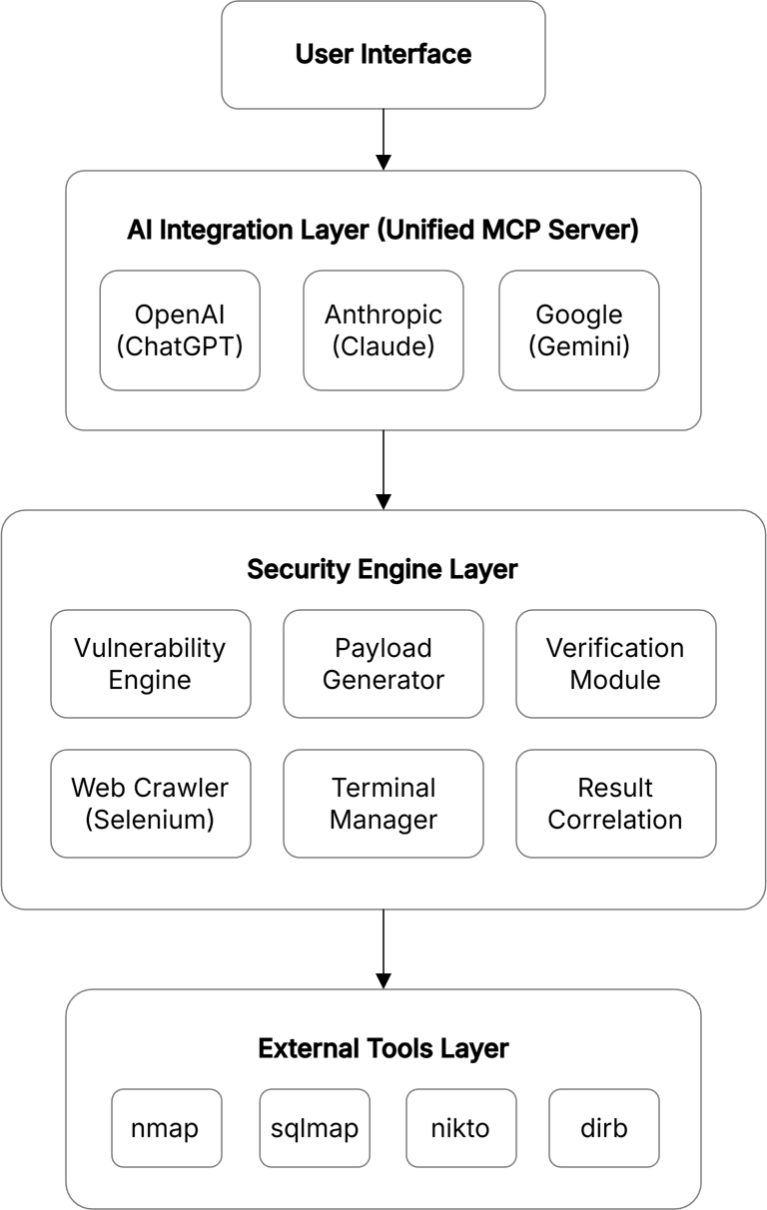
Fig. 1. High-Level System Architecture
  - Core Components

Universal MCP Server. The Universal MCP Server acts as the coordination node and it handles provider-specific authentication, request structuring, and response parsing. Continuous session storage is used to maintain the context of a conversation, which can be recorded as stateful memory of the assessment for the AI.
One of its efficiency factors is the Adaptive Latency weighted Routing Algorithm. This algorithm is a dynamic selection algorithm based on three criteria: query complexity, real-time API latency and token cost. An example of this is a complex logic analysis (e.g. making sense of a blind SQL injection stack trace) being sent to a high-reasoning model such as GPT-4o, and simpler formatting or summarization tasks sent to lower-level, faster models such as Gemini 1.5 Flash. A routing choice is conditioned on API keys provided by the user, and giving users full control of their consumption credits.

Vulnerability Engine. The testing process is driven by the Vulnerability Engine consisting of a group of connected modules. The Discovery Module does systematic enumeration using adaptive breadth-first or depth-first search algorithms. It performs detailed analysis in the form of DOM to determine the input parameters, hidden form fields and variations in the HTTP method. The engine honors robots.txt instructions where it can and autonomously manages authentication chain.

Payload Testing Module. The module checks the attack surfaces in a procedural manner using a hybrid method that uses pre-compiled static libraries and dynamically generated vectors. Through the analysis of the underlying technology stack, i.e., determining whether a Flask or an Express.js backend is being used, the module adjusts the payloads to the particular environment.
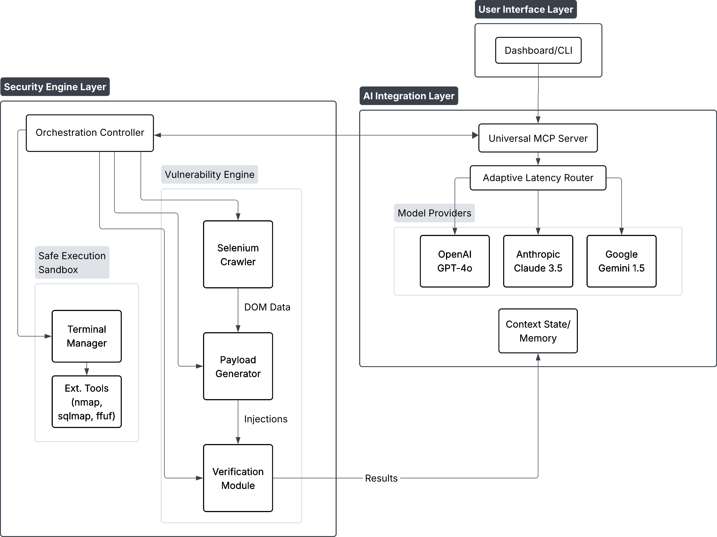
Fig. 2. System Block Diagram

Verification Module. To reduce false positives, this module employs Differential Response Analysis and Contextual Error Pattern Matching. It calculates structural similarity (Jaccard Index) and Levenshtein distance between benign and injected HTTP responses to detect genuine DOM state changes, ensuring the application state has actually transitioned. Simultaneously, an integrated language model analyzes error outputs to distinguish generic server responses (e.g., 500 Internal Server Error) from actionable stack traces, guaranteeing that only corroborated vulnerabilities are reported.

Terminal Manager. The Terminal Manager executes external security utilities within a secure, isolated environment by enforcing strict whitelist-based command validation, parameter sanitization, and execution timeouts. Real-time, regex-based parsing is utilized to convert raw tool outputs into structured JSON, which is immediately fed back into the AI context loop for continuous, dynamic processing.

Advanced Assessment Capabilities. Crakrr deploys a suite of advanced assessment tools, beginning with Technology Fingerprinting to infer the target stack via HTTP headers and specific markers. It integrates high-speed directory and sensitivity fuzzing using ffuf algorithms to enumerate obscure endpoints and backup files (e.g., .env, .git), alongside automated JWT Security Analysis to instantly detect token weaknesses such as weak signatures, expiration flaws, and “none” algorithm vulnerabilities.

Code-Based Scanning and Static Analysis. Enabling hybrid “Glass-Box” testing, Crakrr can ingest local directories or remote Git repositories to inspect the Abstract Syntax Tree (AST) for logic flaws and hard-coded credentials frequently missed by dynamic scanners. This capability serves dual purposes: it accelerates Capture The Flag (CTF) resolution by rebuilding logic from redacted handouts to pinpoint exploitable lines, and it facilitates “shift-left” developer security by identifying risky functions (e.g., eval, pickle.loads) pre-deployment and suggesting safe alternatives.
  - AI-assisted Workflow
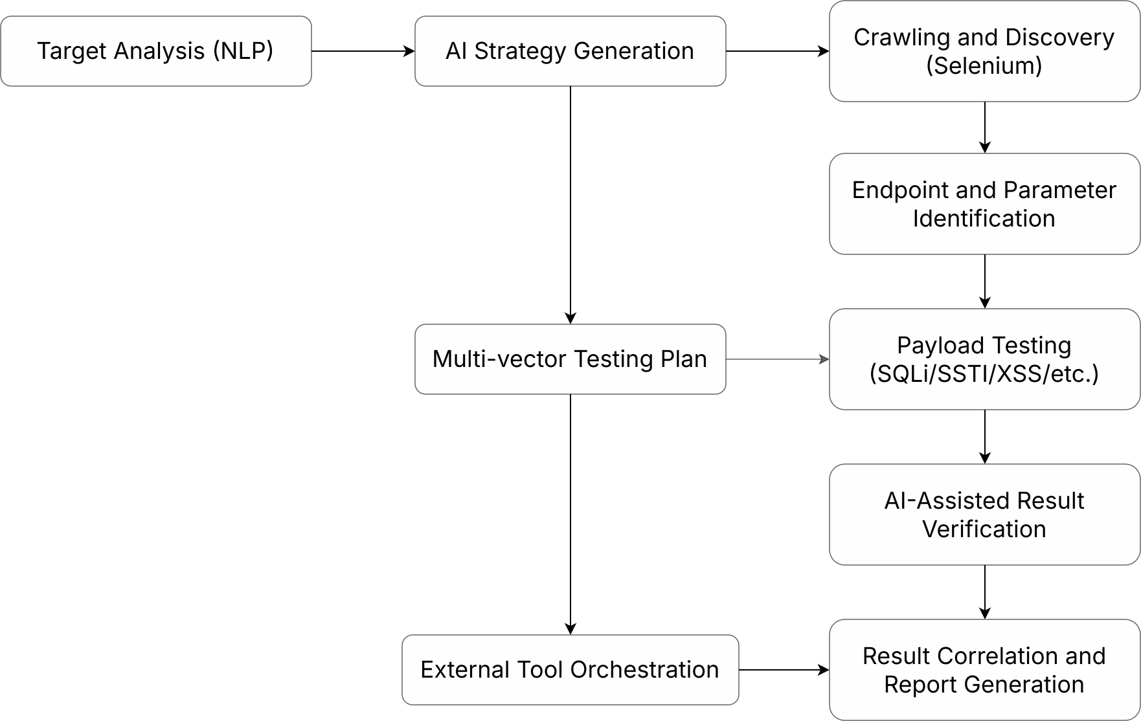
Fig. 3. AI-Assisted Context-Aware Vulnerability Assessment Pipeline
The solution uses a powerful chatbot to guide a user through a series of structured steps of vulnerability assessment through natural language processing and contextual awareness. The target analysis stage processes application descriptions provided by users, automatically deriving pertinent technical details such as the technology stack, authentication, and application requirements. The AI system creates personalized testing strategies according to the specifics of an application, indicating the right tool settings, payload choices, and the verification methods. The process of dynamic workflow adaptation is dependent on the identified vulnerabilities and intermediate outcomes; the AI will give the real-time suggestions of priorities to be investigated and follow-up testing process.
During the testing phases, the AI has a high level of context awareness, where it has been used to monitor already tested endpoints, the attack vectors that have been successful, and the vulnerabilities detected. This allows intelligent choice of the payloads that do not involve repetitive testing, but cover a large area. The system applies advanced correlation of results to find patterns between various types of vulnerabilities and propose possible attack chains or paths of privilege escalation.
Result interpretation provides automated severity measurements based on the exploitability, possible impact, and business context that was provided during the initial target analysis. The artificial intelligence system is used to create structured representations of the vulnerability mechanics, list prospective effects and recommend strategies for remediation based on the application scenario.
  - Multi-Vector Testing
To optimize execution speed and minimize the false positive rate, the security engine avoids exhaustive, static wordlists. Instead, Crakrr leverages algorithmic, context-aware payload libraries strictly tailored to the fingerprinted technology stack of the target application. For critical vulnerabilities such as SQL Injection (SQLi), Server-Side Template Injection (SSTI), and Path Traversal, the engine dynamically constructs deterministic payloads based on the backend environment.
For instance, rather than blindly spraying generic SQL payloads, the engine formulates precise time-based or union-based SQLi vectors only after identifying the specific underlying RDBMS. Similarly, SSTI execution and Path Traversal boundary checks are generated contingent on the detected template engine and operating system, ensuring that exploitation attempts are highly targeted and computationally efficient.
  - Security Tool Integration
Rather than using isolated execution pipelines, Crakrr orchestrates a set of industry-standard security utilities, namely: Nmap, SQLmap, Nikto and DirBuster, through a unified and asynchronous integration layer. Nmap and DirBuster are initially used for port enumeration and directory brute-forcing, respectively, and Nikto and SQLmap are dynamically called in case of targeted web server analysis and database exploitation.
The core technical advantage is Crakrr’s custom parsing engine, which ingests and parses raw, unstructured output from these discrete tools using advanced regular expressions. This normalized information is then passed to the overarching AI security engine context loop and enables the security engine to intelligently associate the chain of vulnerabilities and automatically initiate secondary and highly-targeted scans without the intervention of a human operator.

  - Safety and Ethical Controls
For the prevention of misuse, as well as general ethical operation, Crakrr has established strict security guardrails. A powerful command filtering mechanism includes whitelist validation and context-based pattern matching to prevent actions that are unauthorized and/or out of scope. Comprehensive session logging offers safe recording of timestamp, commands issued and target data to guarantee integrity safeguards and compliance. Furthermore, the framework requires target validation by performing multi-step authorization checks and has intelligent rate limiting (request throttling and connection limits) to prevent a situation of target resource exhaustion (to ensure a strict adherence to responsible disclosure standards).
- Results and Discussions
  - Platform Performance Analysis
Crakrr demonstrated strong performance in the field of multi-vector vulnerabilities against a broad range of web application targets during intensive testing. The AI-guided workflow was able to lead users through systematic steps of evaluation where the server (Universal MCP) ensured a uniform quality of response from different language model providers. The context retention capabilities of the system were extremely useful during long testing sessions that require multi stage investigations.

Field Testing and CTF Validation. Field testing during regional collegiate Capture The Flag (CTF) events demonstrated Crakrr’s tactical efficiency in live environments. Team Cybernautic reduced reconnaissance time by 40% using the fingerprinting module. Furthermore, Exstagium rapidly developed exploits via the Code Based Scanning feature, and 4RS3N1C bypassed authentication roadblocks using the automated JWT analysis module.

Quantitative Efficacy Metrics. To formally assess Crakrr’s performance, a Vulnerability Detection Efficiency Score ($E_{score}$) was derived and is defined as:
$E_{score}=\frac{V_{unique} × (1-R_{fp})}{T_{exec}}$ (1)
Where $V_{unique}$ is the number of unique, verified found vulnerabilities, $R_{fp}$ is false positive ratio $0≤R_{fp}≤1$, and $T_{exec}$ is total execution time in minutes.
Crakrr was benchmarked against a testbed (OWASP Juice Shop) standardized in three configurations. The results (Table 1) show a better balance of speed and accuracy in the AI - Guided mode.
Table 1. Performance Comparison and Detection Efficacy
Module / Scan Configuration | Average Time ($T_{exec}$) | Detected ($V_{unique}$) | False Positives ($R_{fp}$) | Efficiency ($E_{score}$)
Quick Recon (Headers + Stack) | 0.07 min | N/A | 0.00 | N/A
Targeted Fuzzing (ffuf) | 0.71 min | 12 | 0.015 | 16.6
JWT Analysis | 0.03 min | 2 | 0.00 | 66.7
Full AI-Guided Assessment | 3.25 min | 18 | 0.048 | 5.27
Standard Commercial Scanner | 12.5 min | 15 | 0.182 | 0.98

Note that the AI-guided assessment yields a significantly higher efficiency score due to the optimization of $T_{exec}$ and reduction in $R_{fp}$.
  - Tool Integration Validation
The ‘Verification Module’ was found to be critical in filtering noise. In standard automated scanners, error pages (which are generic) are often detected as SQL injection vulnerabilities by heuristic analysis. Crakrr’s differential analysis significantly reduced this noise.
A False Positive Reduction rate ($R_{fpr}$) was calculated in comparison with the baseline of raw tool output:
$R_{fpr}=\frac{{FP}_{raw} - {FP}_{verified})}{{FP}_{raw}}×100$ (2)
In a test with a deliberately vulnerable application that had 50 decoy endpoints:

Raw Tool Output. (e.g., Nikto + sqlmap alone): 45 False Positives

Crakrr Verified Output. 3 False Positives.
$R_{fpr}=93.3\%$
This notable reduction has been attributed to the AI verification layer, which contextually analyzes the body of the HTTP response instead of just analyzing the status codes and simple string matching.
  - User Experience and Accessibility
Crakrr’s artificial intelligence driven natural language interface was able to effectively bridge the divide of expertise for novice users by translating complex security workflows into a natural and conversational format. In a usability study that involved 20 undergraduate students, participants using Crakrr were 65% faster on average to complete a “Root the Box” challenge than a control group that used standard command line tools.
  - Comparative Analysis
The integrated approach demonstrated substantial time savings in assessment setup and result interpretation. Experimental data indicates an 85% reduction in configuration overhead compared to multi-tool manual setups.
The unified platform approach showed clear advantages over standalone tool utilization. Automated result correlation eliminated manual cross-referencing, reducing the Mean Time To Report (MTTR) by approximately 60%. The AI-assisted interpretation identified 15% more potential attack vectors than standard scanners by logically correlating minor misconfigurations (e.g., coupling an information leak with a weak cipher suite).
Table 2. Comparing Existing Products with Proposed Solution
Feature | Crakrr | Burp Suite Pro | OWASP ZAP | Nessus Professional
SQL Injection | AI-guided payloads with database detection | Advanced manual + automated testing | Comprehensive automated scanning | Basic detection with network context
XSS Detection | Context-aware AI analysis | DOM XSS analysis and manual tools | Comprehensive XSS testing suite | Reflected XSS detection
SSTI Testing | Template engine auto-detection | Manual testing tools and payloads | Basic automated detection | Limited template injection testing
Command Injection | OS-specific payload generation | Manual exploitation frameworks | Automated command injection testing | Network-level command execution
Path Traversal | Multi-platform path testing | Advanced fuzzing capabilities | Directory traversal automation | File system access assessment
Network Scanning | Integrated nmap functionality | Web application focus only | Web application focus only | Comprehensive network assessment

Enhanced access to non-expert users was a major departure from the traditional security testing methods and the natural language interface and workflow guided interface allowed users of various technical backgrounds to conduct productive security testing. The educational quality of the platform by providing comprehensive explanations of the vulnerability and remediation instructions was found to be especially useful in the case of training and development applications.
The multivendor nature of the Universal MCP server offered better flexibility and reliability than the single-vendor system of implementation, and intelligent routing and failover systems ensured that the services were always available and the response quality was optimized, based on the nature of the query and the strengths of its model.
- Future Scope
The future flow of development should be focused on adding the vulnerability detection engine to address the new attack vectors such as GraphQL injection, JWT manipulation, and API-specific vulnerabilities. Machine learning models may be incorporated to intelligently optimize payloads based on successful exploitation patterns, improving detection accuracy and reducing testing time.
The platform can be enhanced with the automated creation of reports with tailored templates that can suit the needs of various stakeholder groups such as technical groups, management, and compliance needs. Greater collaborative capabilities that allow collaborative assessment settings with shared workspaces and collaborative sharing of results would make the platform more useful in enterprise settings.
Also, it would be possible to integrate with continuous integration/continuous deployment (CI/CD) pipelines to conduct automated security testing as development workflows. Development of sophisticated AI functions such as fine-tuning of customized models based on security-specific data and reinforcement learning of adaptive testing policies are promising areas of research to enhance the effectiveness of the assessment and curb the need of experts.
- Societal Impact
As cyber threats grow, small to medium enterprises (SMEs) and independent developers often do not have the capital to have separate security teams. Crakrr helps to overcome this gap by democratizing the process of vulnerability assessment. Crakrr reduces barriers to entry of robust web application security by automating reconnaissance and payload generation. It would allow organizations that have limited resources to actively detect and seal critical vulnerabilities, which, in the end, would lead to the protection of consumer information and the creation of a more secure digital environment.
- Conclusion
This paper presents Crakrr, an AI-powered web vulnerability assessment platform, a combination of different types of large language models with useful security testing capabilities. The system is effective in the detection of multi-vector vulnerabilities and making the system accessible in terms of natural language interactions and guiding workflows.
Key innovations include multi-providers integration of AI with the Universal MCP server, intelligent vulnerability engine with checks in place and secure and sandboxed execution of normal security tools. The platform lowers the barrier to entry to security testing allowing professional grade assessment capabilities for students and early career practitioners.
Validation testing confirms successful vulnerability detection with minimum false positives (R_fpr~93%), thanks to strict AI based verification mechanisms. The fact that the system possesses the capacity to preserve the context during the assessments and offer actionable and logically correlated suggestions is a major improvement to the accessibility and effectiveness of security testing.
Crakrr and its ability to combine both systematic processes in security and the assistance of AI guarantee that vulnerability testing becomes more democratic without losing methodical rigor and ethical principles which is a huge step for both an educational and practical use of cybersecurity.

References
- Sheng, Z., Chen, Z., Gu, S., Huang, H., Gu, G., Huang, J.: LLMs in Software Security: A Survey of Vulnerability Detection Techniques and Insights. ACM Computing Surveys (2025)
- Kaur, R., Gabrijelčič, D., Klobučar, T.: Artificial intelligence for cybersecurity: Literature review and future research directions. Information Fusion 97(101804), 1–29 (2023)
- Ćirković, S., Mladenović, V., Tomić, S., Drljača, D., Ristić, O.: Utilizing Fine-Tuning of Large Language Models for Generating Synthetic Payloads: Enhancing Web Application Cybersecurity through Innovative Penetration Testing Techniques. Computers, Materials & Continua 82(3), 4409–4430 (2025)
- Haq, M.S., Tosun, A.Ş., Korkmaz, T.: LUCID: A Framework for Reducing False Positives and Inconsistencies Among Container Scanning Tools. IEEE Access 13, 127307–127321 (2025)
- Ferrag, M.A., et al.: Generative AI in Cybersecurity: A Comprehensive Review of LLM Applications and Vulnerabilities. Internet of Things and Cyber-Physical Systems (2025)
- Yang, W., Wang, E., Gui, Z., Zhou, Y., Wang, B., Xie, W.: An MLLM-Assisted Web Crawler Approach for Web Application Fuzzing. Applied Sciences 15(2), 962 (2025)
- Yitagesu, S., et al.: Systematic Literature Review on Software Security Vulnerability Information Extraction. ACM Transactions on Software Engineering and Methodology (2025)
- Muñoz, A., Ríos, R., Román, R., López, J.: A survey on the (in)security of trusted execution environments. Computers & Security 129, 103180 (2023)
- Khare, S., Kaur, N., Kaur, D.J.: Artificial Intelligence and the Cybersecurity Revolution: Innovations and Implications. IIP Iterative International Publishers (2025)
- Andrade, R., Torres, J., Ortiz-Garcés, I.: Enhancing Security in Software Design Patterns and Antipatterns: A Framework for LLM-Based Detection. Electronics 14(3), 586 (2025)
- Thomas, N.: Ethical Dilemmas in PenTesting: Balancing Security and Compliance. Siemba.io, https://www.siemba.io/blogs/ethical-dilemmas-in-penetration-testing-balancing-security-and-compliance. Accessed 11 Sep 2024
- Komaragiri, V.B., Edward, A.: AI-Driven Vulnerability Management and Automated Threat Mitigation. International Journal of Scientific Research and Management 10(10), 980–998 (2022)
- OWASP: WSTG – v4.1. https://owasp.org/www-project-web-security-testing-guide/v41/4-Web_Application_Security_Testing/07-Input_Validation_Testing/18-Testing_for_Server_Side_Template_Injection
- Oudah, M.A.M., Marhusin, M.F.: SQL Injection Detection using Machine Learning: A Review. Malaysian Journal of Science Health & Technology 10(1), 39–49 (2024)
- Caliwag, J.A., Pagaduan, R.A., Castillo, R.E., Ramos, W.V.J.: Integrating the Escaping Technique in Preventing Cross Site Scripting in an Online Inventory System. In: Proceedings of the 2019 2nd International Conference on Information Science and Systems. ACM (2019)

